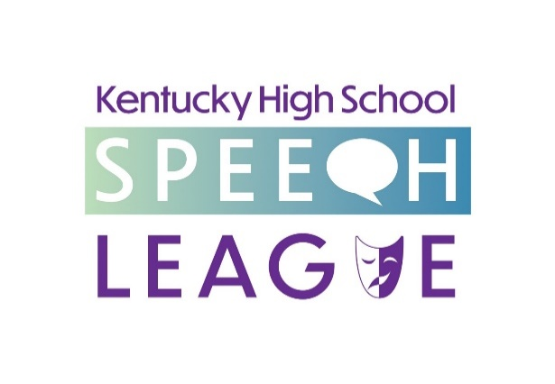

19 May 2020
FOR IMMEDIATE RELEASE

(LEXINGTON – AND THE WORLD WIDE WEB)
The Kentucky High School Speech League completed its virtual Senior High School State Speech Tournament on Monday with an awards ceremony video streamed on YouTube. Students from Morehead to Murray competed in fourteen speech events as a culmination of the year’s competitive high school speech season in a state tournament rescheduled from March, when the in-person meet (to have been held at the University of Louisville) was postponed. This was KHSSL’s first online event and also served to mark its 100th year of state competitions, as the first KHSSL statewide debate was held in 1921 with speech events added the next year.

Rowan County Senior High School claimed the state title for a fourth time, having last won in 2015. Their squad placed twenty-seven entries into the awards rounds (top 14) with fifteen of those advancing on into the trophy rounds (top six). Second was Lexington Dunbar, followed by Knott County Central, Murray High, Lexington Henry Clay, LaRue County, Danville High, Larry A Ryle (Boone County), Bardstown Bethlehem, and Bowling Green High as the top ten teams.

State champions were crowned in each event after student participated in three preliminary rounds, a semifinal round, and the finals for the top six. Students recorded speeches ahead of time in ten of the events; the four limited preparation events recorded over four different days in short windows of time. All rounds were scored by judges across the state with feedback ballots submitted via the Internet, and announcements of awards and advancements from preliminary and semifinal rounds were all via YouTube video with links on the League’s Facebook and Twitter. Executive Director Steve Meadows noted that, “while the virtual contest was roughly half the size of what we had enrolled for the in-person meet we had to cancel two days before it began, we were very happy to be able to provide this contest to our schools so that their students, especially their seniors, could have this important part of their spring activities still happen for them, especially as a capstone event for this, our one hundredth year of contests.” The League had previously held in-person state debate and junior high speech contests before the pandemic shut down such events as well as fourteen regional tournaments around the state after the end of the invitational season.

State champions in each event were Broadcast Announcing: Parker Smith (Lexington Dunbar); Declamation: Olivia Conley (Knott County Central); Dramatic Interpretation: Jack Neel (Bardstown Bethlehem); Duo Interpretation: Dalia Basinac and Elliet Malatesta (Larry A. Ryle); Extemporaneous Speaking: Gabriella Staykova (Lexington Dunbar); Humorous Interpretation: Dakota Perry (Rowan County); Impromptu Speaking: Sadie Bograd (Lexington Dunbar); Improvisational Duo: Chellam Antony and Kat Jenkins (Murray High); Informative Speaking: Maya Ganesh (Bowling Green High); Oratory: Laurel Riggs (Bardstown Bethlehem); Poetry: Kaitlin Slone (Knott County Central); Program Oral Interpretation: Jack Neel (Bardstown Bethlehem); Prose: Stefanie Giles (LaRue County); Storytelling: Libby Hale (Danville High).

Bardstown High School’s Catherine Christian was voted Coach of the Year by her peers. Danville’s Samantha Sallee was the winner of the Blyton Book Award; Lexington Henry Clay’s Abby Hardin won the Blyton Scholarship. Knott County Central gained one year’s possession of the trophy for Sustained Excellence, an honor schools win with accumulated points over time that rewards a school’s commitment to speech education over many years.

For further information about the League, full results of the contest, to see the awards announcement videos, or any other information, please contact Executive Director Steve Meadows and visit our website at www.khssl.org.

Steve Meadows, Executive Director, KHSSL, Inc.
(859) 927-1100 khsslboard@gmail.com
www.khssl.org @khssl

